How to make the output of the file secret?
Sam
The key thing is to design some rules which is unknown to others but known to yourself. For example, the following code plus some print-writer or formatter can create the “secret” file only the designer knows.

for(int row = 0; row < storeNewInfo.length; row ++ )
{
/*
* Very important:
* DON'T CHOOSE OPERATING ASCII-2 AS RANDOM CHARS!!!
*/
for(int column = 0; column < storeNewInfo[row].length; column++)
{
storeNewInfo[row][column] = (char)(33 + Math.random() * 95) +
storeNewInfo[row][column] + (char)(33+ Math.random() * 95);
}
}//end outer for

But the special thing is that you can not choose the operating symbols in ASCII (Such as line feeds, delete, etc.) Or your program will be in a messey.

Codes for writing things:

infoList.clear();

for (String[] storeNewEachLine : storeNewInfo)
{
eachLine = "";
for (String storeNewEachCell : storeNewEachLine)
{
eachLine += storeNewEachCell + " ";
}//end inner for

infoList.add(eachLine);
}//end outer for

try {
Formatter writer = new Formatter( new File("bin/Person Info.exo"));

for(int index = 0; index < infoList.size(); index++)
writer.format("%s\n", infoList.get(index));

writer.close();

} catch (FileNotFoundException e) {
JOptionPane.showMessageDialog(errorFrame, "Store information failed! Error: 02."
+ "Please contact technology person!");
}//end try-catch

The output of the file been written will be like this:

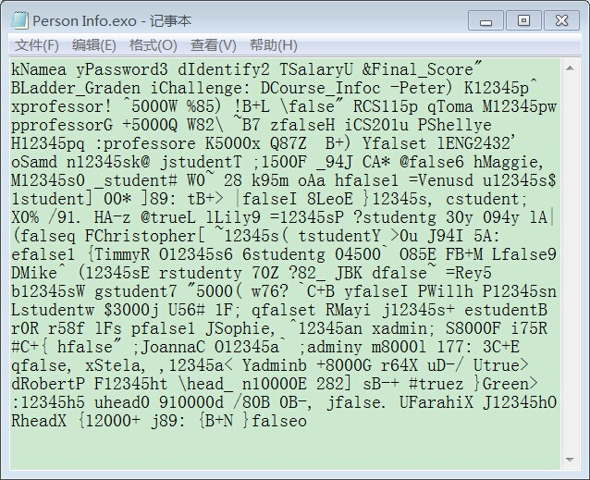

So if you don’t know the rule that these information was in each cell the program add a random character before and after the real information correspondingly, it will be very difficult for you to figure out even if you get this file.

Since you already know how to make the file secret, you can read the information by deleting the generated random character, like this:

for(int row = 0; row < infoList.size(); row++)
{
storeInfo[row] = new String
[infoList.get(row).toString().split(" ").length];
storeInfo[row] = infoList.get(row).toString().split(" ");

for(int column = 0; column < storeInfo[row].length; column++)
{
String newString = "";
/*
* Sarted from index 1 and omit the last index of String,
* thus cancel out the random number.
*/
for(int index = 1; index < storeInfo[row][column].length() - 1; index++)
newString += storeInfo[row][column].charAt(index);

storeInfo[row][column] = newString;
}//end inner for
}//end outer for

for(int row = 0; row < storeInfo.length; row ++ )
{
for(int column = 0; column < storeInfo[row].length; column++)
System.out.print(storeInfo[row][column] + " ");

System.out.println();
}//end out for

return storeInfo;

Thus you will get regular information such as:

